# Dis-Eur-UK-Kent-Northfleet-****Middle Paleolithic,**** Mousterian, 60,000 - 40,000 BP-Museum of London-British Museum

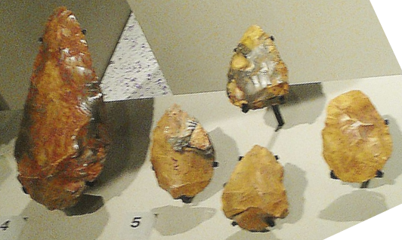

Lithics from Swanscombe on display at the [Museum of London](https://en.wikipedia.org/wiki/Museum_of_London)

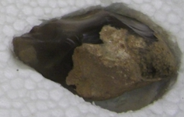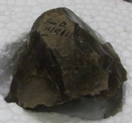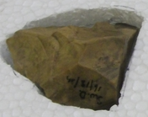

British Museum

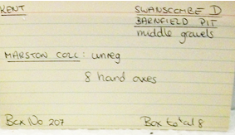

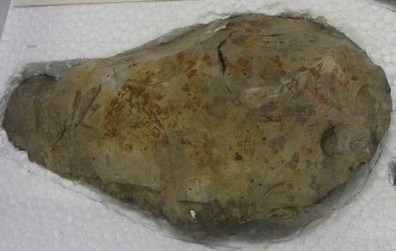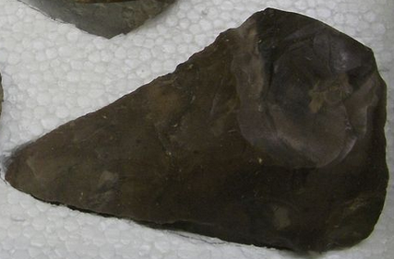 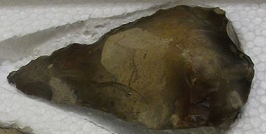

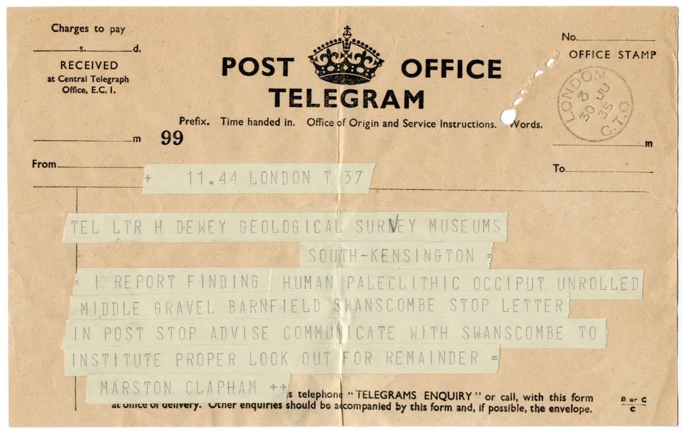

Bone fragments and tools, representing the earliest humans known to have lived in England, have been found from 1935 onwards at the *Barnfield Pit* about 2 km (1 mile) outside the village. This site is now the [Swanscombe Heritage Park](https://en.wikipedia.org/wiki/Swanscombe_Heritage_Park). [Swanscombe Man](https://en.wikipedia.org/wiki/Swanscombe_Man) (now thought to be female) was a late [*Homo erectus*](https://en.wikipedia.org/wiki/Homo_erectus) or an early [Archaic *Homo sapiens*](https://en.wikipedia.org/wiki/Archaic_humans).[[2]](https://en.wikipedia.org/wiki/Swanscombe#cite_note-2) The c. 400,000-year-old skull fragments are kept at the [Natural History Museum](https://en.wikipedia.org/wiki/Natural_History_Museum,_London) in [London](https://en.wikipedia.org/wiki/London) with a replica on display at the Dartford Museum. Lower levels of the Barnfield Pit yielded evidence of an even earlier, more primitive human, dubbed [Clactonian Man](https://en.wikipedia.org/wiki/Clactonian_Man).

The area was already famous for the finds of numerous [Palaeolithic](https://en.wikipedia.org/wiki/Palaeolithic)-era [handaxes](https://en.wikipedia.org/wiki/Handaxe)—mostly [Acheulean](https://en.wikipedia.org/wiki/Acheulean) and [Clactonian](https://en.wikipedia.org/wiki/Clactonian) artifacts, some as much as 400,000 years old—when in 1935/1936 work at Barnfield Pit uncovered two [fossilised skull fragments](https://en.wikipedia.org/wiki/List_of_human_evolution_fossils). These fragments came to be known as the remains of **Swanscombe Man**, a name they retained despite a re-identification that established that they had belonged to a young woman.[[1]](https://en.wikipedia.org/wiki/Swanscombe_Heritage_Park#cite_note-1) These remained the oldest human fossils discovered anywhere in the UK, until the 1994 and 1995 discoveries of 500,000-year-old human leg bones and teeth at [Boxgrove](https://en.wikipedia.org/wiki/Boxgrove_Quarry).

The Swanscombe skull has been identified as [*Homo heidelbergensis*](https://en.wikipedia.org/wiki/Homo_heidelbergensis). It dates to the [Hoxnian Interglacial](https://en.wikipedia.org/wiki/Hoxnian_Stage) 400,000 years ago, and since this follows the extreme [Anglian ice age](https://en.wikipedia.org/wiki/Anglian_%28stage%29) which drove humans out of the British Isles, the Swanscombe people must represent a re-colonisation.[[2]](https://en.wikipedia.org/wiki/Swanscombe_Heritage_Park#cite_note-2)

The skull fragments were found in the lower middle terrace gravels at a depth of almost 8 metres beneath the surface. They were found by Alvan T. Marston, an amateur archaeologist who visited the pit between quarrying operations to search for flint tools. A third, matching fragment of the same skull was found in 1955 by Bertram and John Wymer.

Further excavations, carried out between 1968-1972 by Dr. [John d'Arcy Waechter](https://en.wikipedia.org/w/index.php?title=John_d%27Arcy_Waechter&action=edit&redlink=1), uncovered more animal bone and flint tools, and established the extent of a former shoreline that the bones were found on.

Most of the bone finds are now in the [Natural History Museum](https://en.wikipedia.org/wiki/Natural_History_Museum,_London) in [London](https://en.wikipedia.org/wiki/London), with the stone finds at the [British Museum](https://en.wikipedia.org/wiki/British_Museum).

The other key [paleolithic](https://en.wikipedia.org/wiki/Paleolithic) sites in the UK are [Happisburgh](https://en.wikipedia.org/wiki/Happisburgh), [Pakefield](https://en.wikipedia.org/wiki/Pakefield), [Pontnewydd](https://en.wikipedia.org/wiki/Bontnewydd_Palaeolithic_site), [Kents Cavern](https://en.wikipedia.org/wiki/Kents_Cavern), [Paviland](https://en.wikipedia.org/wiki/Red_Lady_of_Paviland), and [Gough's Cave](https://en.wikipedia.org/wiki/Cheddar_Man).

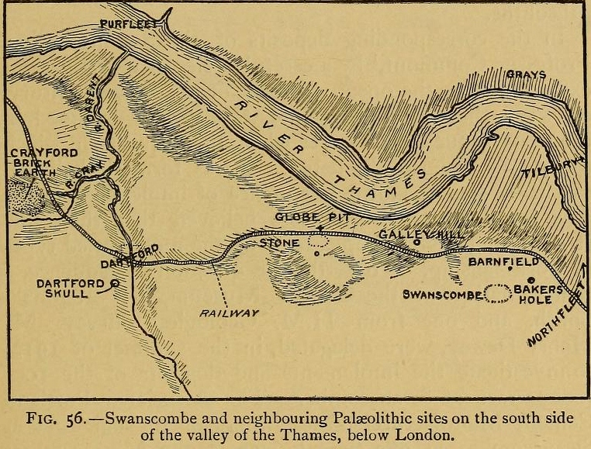from "Antiquity of Man" via archive.or